carrying capacity (K) of ten million fish

The simulation begins with a fish population density (n/K) in the range of 0.3 � 0.5.

The coastal fishery consists of a number of vessels whose success depends, in large part, on the density of the fish in the region.

* If population density is high, their annual catch increases;
* as population density falls, so does their harvest.
* The net revenues per vessel is directly proportional to their annual catch, as well as the average price-per-fish that they obtain.

The number of vessels added to the fishery depends on economic conditions, specifically the ratio of the average return per vessel and the cost of a new vessel.

* Assume that the average lifetime of a boat is ~ 20 years,
* each year about 5% of the fleet is taken out of service.

You could use an aging chain (two stocks) to represent juvenile and adult fish, or you could ignore this distinction and simply have the total fish as a stock. In either case, the birth and death fractions depend on the fish density, similar to the logic in the fish problem for exercise 1.

Fish caught could be approximated as the product of vessels, max yield (see below), and fish density.

This problem builds on the general population model concepts explored in Ex 1 Fish Population, but introduces the efects of an economy that depends on the harvest of the fish for its viability.

We move from a simple model of a small pond with a carrying capacity of 1000 fish to a vast coastal region of several thousand square miles, with a carrying capacity (K) of ten million fish of the type that are the mainstay of the fishery economy. (Don�t be intimidated by the difference in scale�it doesn�t significantly impact the complexity of the population-model portion of this exercise).

The simulation begins with a fish population density (n/K) in the range of 0.3 � 0.5.

The coastal fishery that depends on the harvest of these fish consists of a number of vessels whose success depends, in large part, on the density of the fish in the region.�If population density is high, their annual catch increases; as population density falls, so does their harvest.This is of great concern to the fleet, of course.�The net revenues per vessel is directly proportional to their annual catch, as well as the average price-per-fish that they obtain.

The number of vessels added to the fishery depends on economic conditions, specifically the ratio of the average return per vessel and the cost�of a new vessel.�Assume that the average lifetime of a boat is ~ 20 years, meaning that each year about 5% of the fleet is taken out of service.

You could use an aging chain (two stocks) to represent juvenile and adult fish, or you could ignore this distinction and simply have the total fish as a stock.�In either case, the birth and death fractions depend on the fish density, similar to the logic in the fish problem for exercise 1.�

Fish caught could be approximated as the product of vessels, max yield (see below), and fish density.

The goal of this model exercise is to explore the feedback processes between fishing pressure, fish population density, and the economic health of the commercial fishery.�Your work should focus on establishing a �baseline� model of the fishing fleet and fish population, and then explore various �what-if� scenarios, both those indicated below as well as others of your own devising.

Although RBPs are shown below, your goal should NOT necessarily be to exactly replicate the behavior shown, as the output of your model will depend strongly on the kind of assumptions you make and the level of detail you choose to include in the economic factors that influence fleet size changes, for example.�However, the graphs below may provide you with some general idea of the kind of behavior you might expect to see.

Some starting points for your modeling work include the following:

* Simulation time period : 50 years
* Initial fish population : ~ 3E6 � 5E6
* Carrying capacity (K) : 1E7
* Maximum reproduction rate : ~ 1 � 1.2
* Minimum death rate : 0.1
* Time for fish to mature : 2 years (if you use two storages)
* Initial number of fishing craft : 20-50
* Cost of new vessel:�$100,000 - $200,000
* Maximum yield (annual catch per craft at n/K=1) : 50,000-100,000 fish
* Revenue per fish : $2 -$3

Begin by specifying and calibrating your model to begin in equilibrium by adjusting initial values and parameters. (RBP is straight lines for vessels and fish).

Now increase the number of vessels by 50%.�Sample RBP:

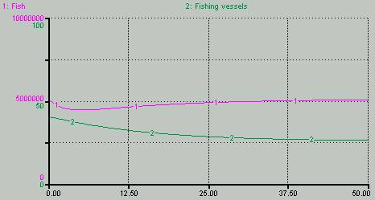

Questions for you to address might include:

1)�What feedback loops are present in your model?�How do they influence its behavior?

2)�What happens with different INITIAL VALUES for fish population and/or fleet size?�What happens when you change various parameters such as revenue-per-fish, K, Maximum yield, etc.?

3)�How would you model a major subsidy that cuts the effective cost of vessels in half after, say, five years?What happens?�On top of this, what if K were to degrade linearly over 50 year run to half its value?�How would you model this.�Here is an example RBP for this case:

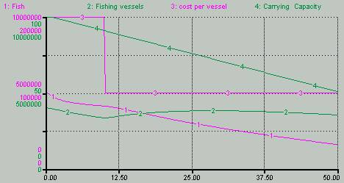

4)�Time permitting:�how might you introduce a supply-and-demand logic that causes revenue-per-fish to vary with total harvest...in other words, in years when the catch is low, the price-per-fish increases and vice-versa?�Analyze the impact variable pricing has on the number of vessels and the fish population.

5)�Also, or alternatively, time permitting, consider other decision rules for adding vessels than simply making the inflow proportional the ratio of income per vessel to vessel cost.�How do different rules change the behavior?

Exercise 1 Fish Population Model

* Initial fish population, N(t=0) = 100
* Carrying Capacity, K=1000
* Total Simulation Time = 36 months
* Maximum Birth Rate = 0.5 (in other words, no more than 50% of the population reproduces in any time period)
* Minimum Death Rate = 0.1 (at least 10% of the fish population dies in any time period)

Stocks:

Juvenile fish

Adult Fish

Flows:

Max Birthing Rate

Min Dying Rate

Maturing Rate

Constants:

Carrying Capacity

Variables:

Fish Population Density

Minimum Death Fraction

Current Death Fraction

Maximum Birth Fraction

• Define/articulate the Issue/Problem (focus the effort)

* explicit purpose
* Reference Behavior Pattern (RBP)

**Reference Behavior Pattern is the actual behavior of the real world**.  It could be described qualitatively as prose, or quantitatively in tabular or graphical format.

* + select one or two key measureable aspects of the real world that summarize or encapsulate the behavior of interest
  + document the values over time for these key aspects
  + should capture the essential qualitative behavior
  + growth, oscillation, growth followed by stagnation, overshoot & collapse, perpetual delays, etc.
* diagram

• Formulate Model

* Develop & Represent Dynamic Hypothes[es]
  + dynamic organizing principle
  + map the hypotheses
* Think operationally: make the map simulatable
  + id. storages
  + characterize flows
  + id. feedback loops
  + specification and calibration (determine equations & parameters)

• Test Model

* Debugging
  + mechanical mistake tests
  + robustness tests
  + diagnosing surprise behavior
* Verification
  + understanding model behavior/dynamics
  + hypothesis tests
  + exploring dynamic behavior
* Validation
  + replicate RBP
  + challenge the boundaries (extensive & intensive)

• Model Application & Transfer

* Design and Evaluate Policies
  + policy/theory
  + sensitivity
  + scenarios
* Make Learning Available (communicate)
  + develop a drama
  + design a learning progression
  + implement a learning progression
  + create in-character feedback and coaching sequences